TRAINITY

**PROJECT – 2**

**Instagram User Analytics**

Submitted By

**BOJJA JAHNAVI**

Data Analytics Trainee

Submitted On:- 11-10-2023

**Instagram User Analytics**

**Project Description:**

The project Instagram User Analytics is to analyze the analytics of Instagram. The process is done by understanding the data of user interactions with the Instagram and providing valuable insights from them. As a Data Analyst my role is to track the users interaction with the Instagram and derive insights to the growth of the organization. The main purpose of this project is to provide a clear understanding of the usage of Instagram. This promotes to establish new applications in Instagram according to the users flexibility.

The analytics of the project is done in two sections. They are

1. Marketing Analysis
2. Investor Metrics

We will look into brief about the process of Instagram user analytics by executing the queries and giving the outputs.

**Approach:**

Start the project by creating database named as ig_clone. Then use the database and create tables by the data provided. Insert various cloumns in the tables and start executing the queries.

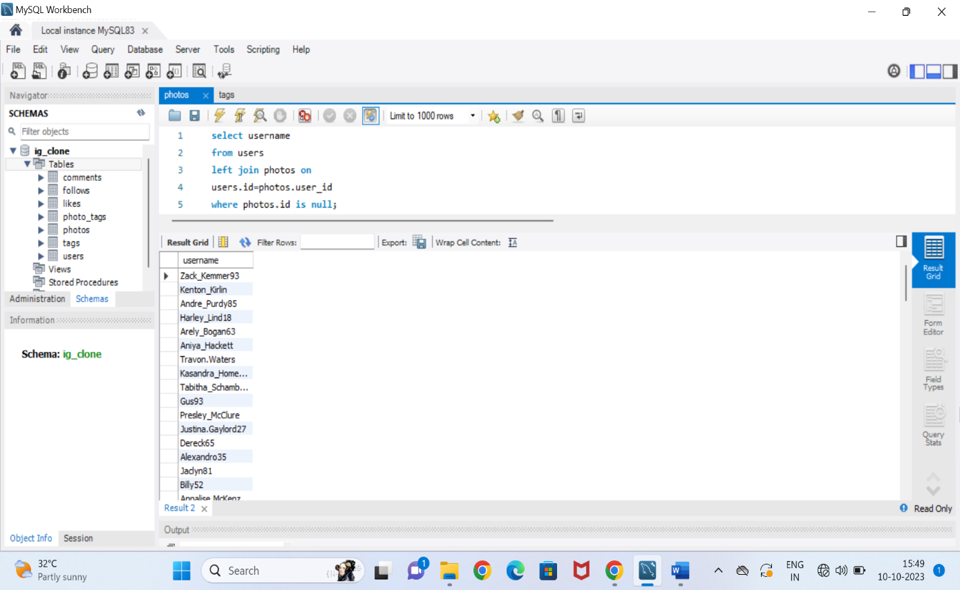

The above picture shows the database, table names

1. **Marketing Analysis:**
2. Loyal User Reward: A loyal user reward is given to the users who had been using the Instagram since long years. So 5 oldest users of Instagram are found by applying required queries of Sql.

Oldest Users of Instagram:

**Query:**

SELECT * FROM users

order by created_at

limit 5;

**Output:** The 5 oldest users of Instagram are

Darby_Herzog

Emilio_Bernier52

Elenor88

Nicole71

Jordyn.Jacobson2

1. Inactive User Engagement: Inactive users are those who doesn’t post even a single photo on Instagram. They are identified and sent promotional mails to post the photos on Instagram.

Users who have not posted any single photo:

**Query:**

select username

from users

left join photos on

users.id = photos.user_id

where photos.id is null;

**Output:**

The inactive users who have never posted a single photo are Zack_Kemmer93, Kenton_Kirlin, Andre_Purdy85, Harley_Lind18, Arely_Bogan63 etc.

1. Contest winner Declaration: A contest was organized where a user is declared as winner who has more likes for a single photo. We have to determine the winner of the contest and provide their details.

Winner of the contest and their details:

**Query:**

select id, username

from users

where id= (select user_id

from photos

where id= (select photo_id

from likes

group by photo_id

order by count(photo_id) desc

limit 1));

**Output:**

The winner of the contest is **Zack_Kemmer93** with **id number 52**.

1. Hashtag Research: The most popular Hashtags are found to post that increases the brand value. Top 5 hashtags are considered to promote the brand value.

Top 5 commonly used Hashtags:

**Query:**

select tag_id, tag_name, count(tag_id) as Total

from tags

inner join photo_tags on

tags.id=photo_tags.tag_id

group by tag_id

order by count(tag_id) desc

limit 5;

**Output:**

The 5 top most hashtags are –

1. Smile
2. Beach
3. Party
4. Fun
5. Concert
6. Ad Campaign Launch: The team want to launch the ads on a best day when there is high registrations by the users.

Scheduling the ad campaign:

**Query:**

Select dayname(created_at) as day, count(*) as Total

From users

Group by day

Order by Total desc

Limit 1;

**Output:** The ad campaign can be scheduled on **Thursday** as the number of users registered on that day is more.

1. **Investor Metrics:**
2. User Engagement: The team want to know whether the users are active or inactive by finding out the average photos posted by the users.

Average posts per user:

**Query:**

Select

(Select count(*) from photos) /

(select count(*) from users) as avg;

Select

(Select count(*) from photos)/

(select count(id) from users) as Total_posts_to_Total_Users

**Output:**

The Average number of posts per user on Instagram are **257.000**

The total posts to total users is **3.4730**

1. Bots and Fake Accounts: The investors want to know the fake accounts by identifying the users who have liked all the photos that are posted on Instagram.

Potential bots who liked every photo:

**Query:**

select id, username

from users

where id in (select user_id

from likes

group by user_id

having count(user_id)=(select count(id) from photos));

**Output:**

There are some Fake accounts found from the users. The usernames are

**id username**

5 - Aniya_Hackett

14 - Jacln81

21 - Rocio33

24 - Maxwell.Halvorson

36 - Ollie_ledner37

41 - Mckenna17

54 - Duane60

57 - Mike.Auer39

71 - Nia_Haag

75 - Leslie67

76 - Janelle.Nikolause81

91 - Bethany20

**Tech-Stack Used:**

MySQL Workbench with 8.0.34 version. The software is easy to write the queries and Used execute the modified solutions in the form of outputs. The Inputs are given in the form of sql queries which are very flexible to execute.

**Insights:**

1. **Marketing Analysis:**
2. **Loyal User Reward:**

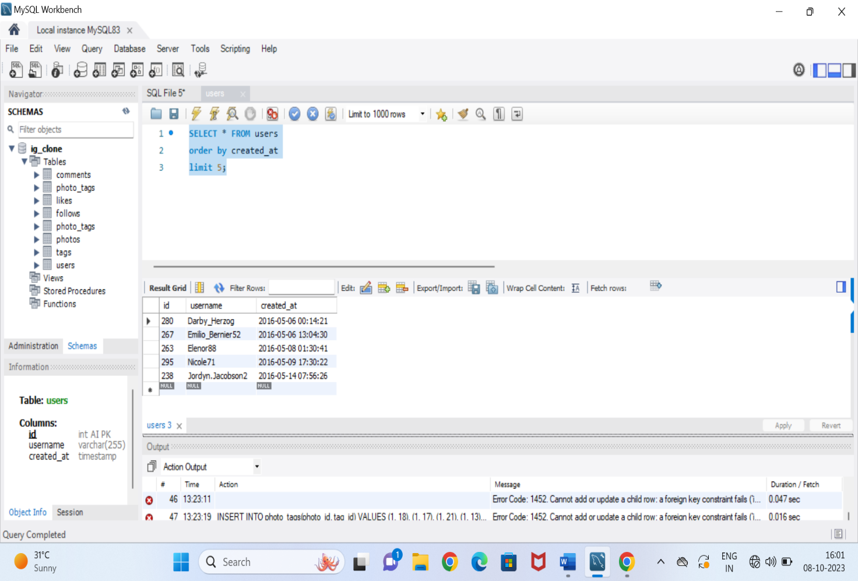

The 5 oldest users of Instagram are Darby_Herzog, Emilio_Bernier52, Elenor88, Nicole71, Jordyn.Jacobson2.

1. **Inactive User Engagement:**

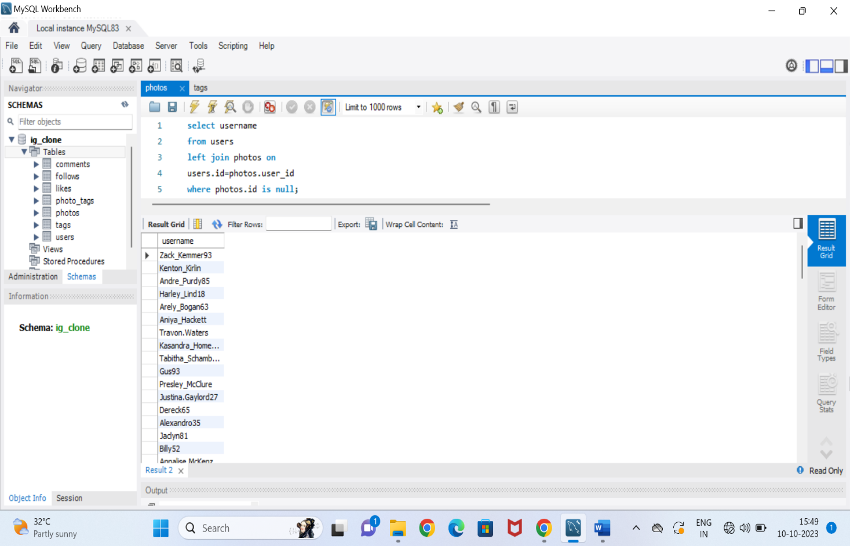

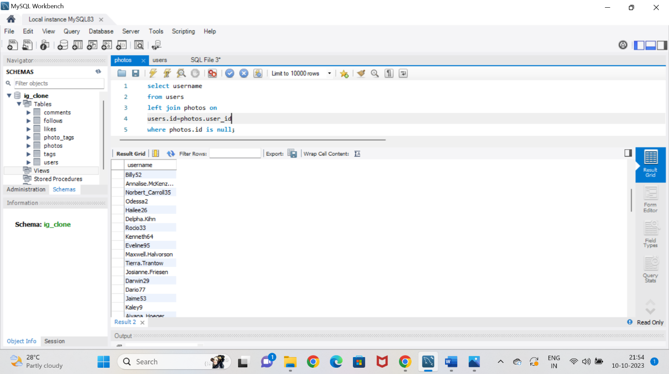 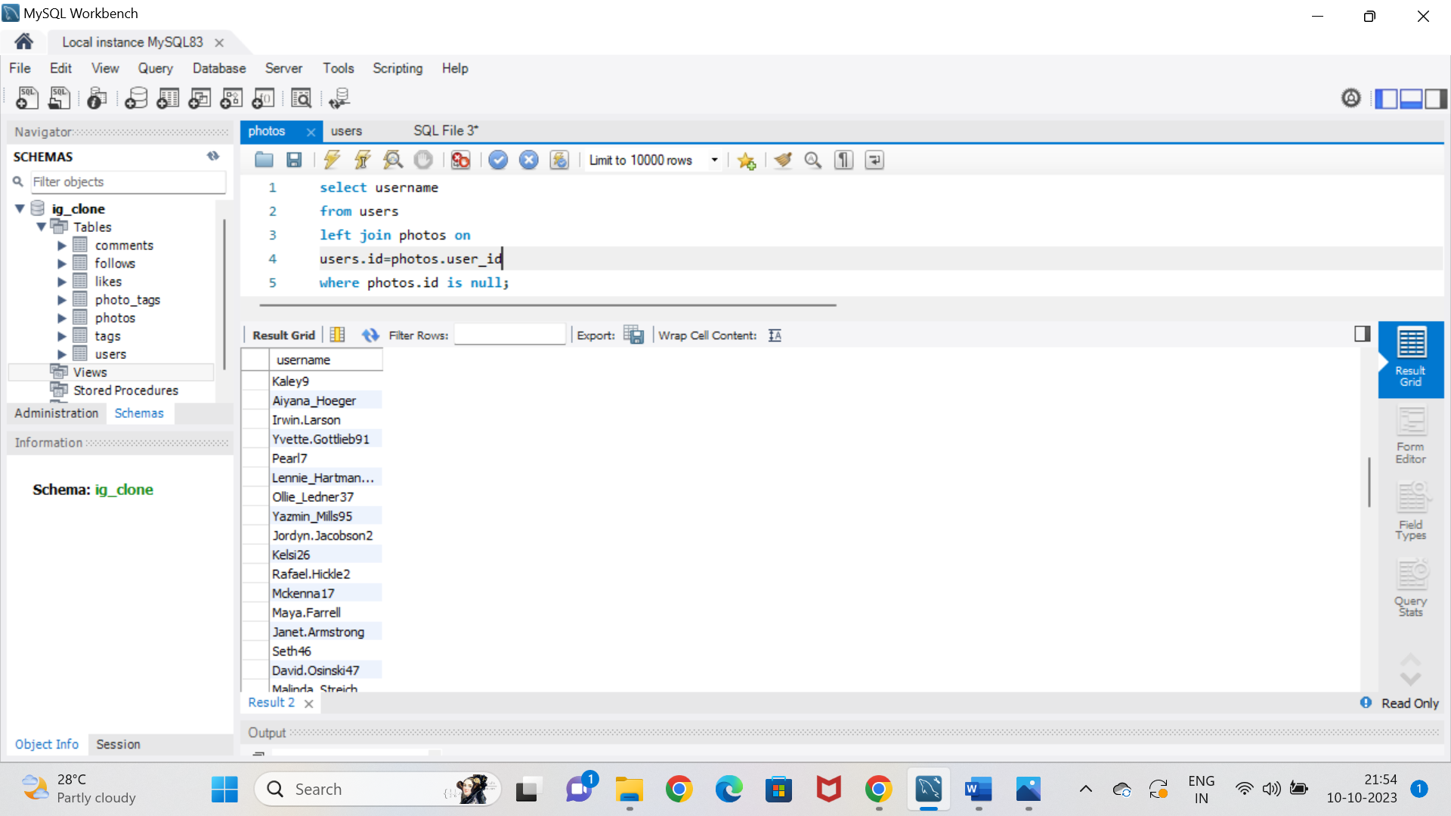

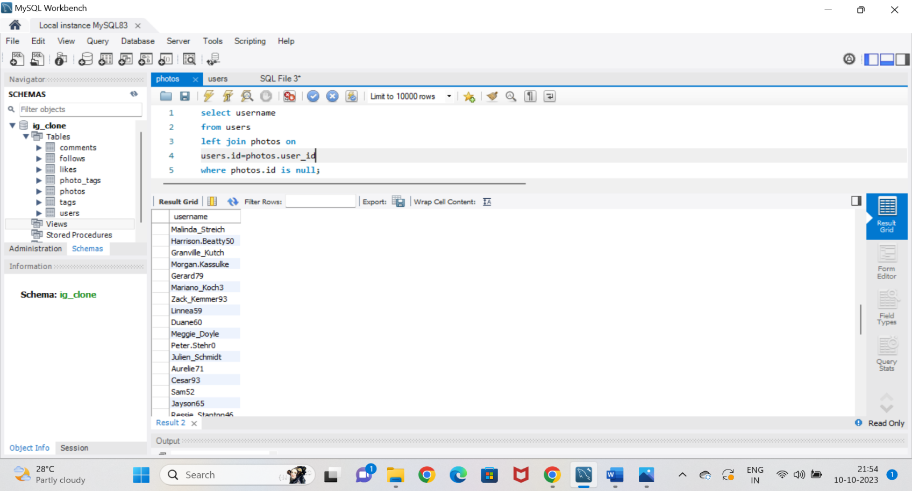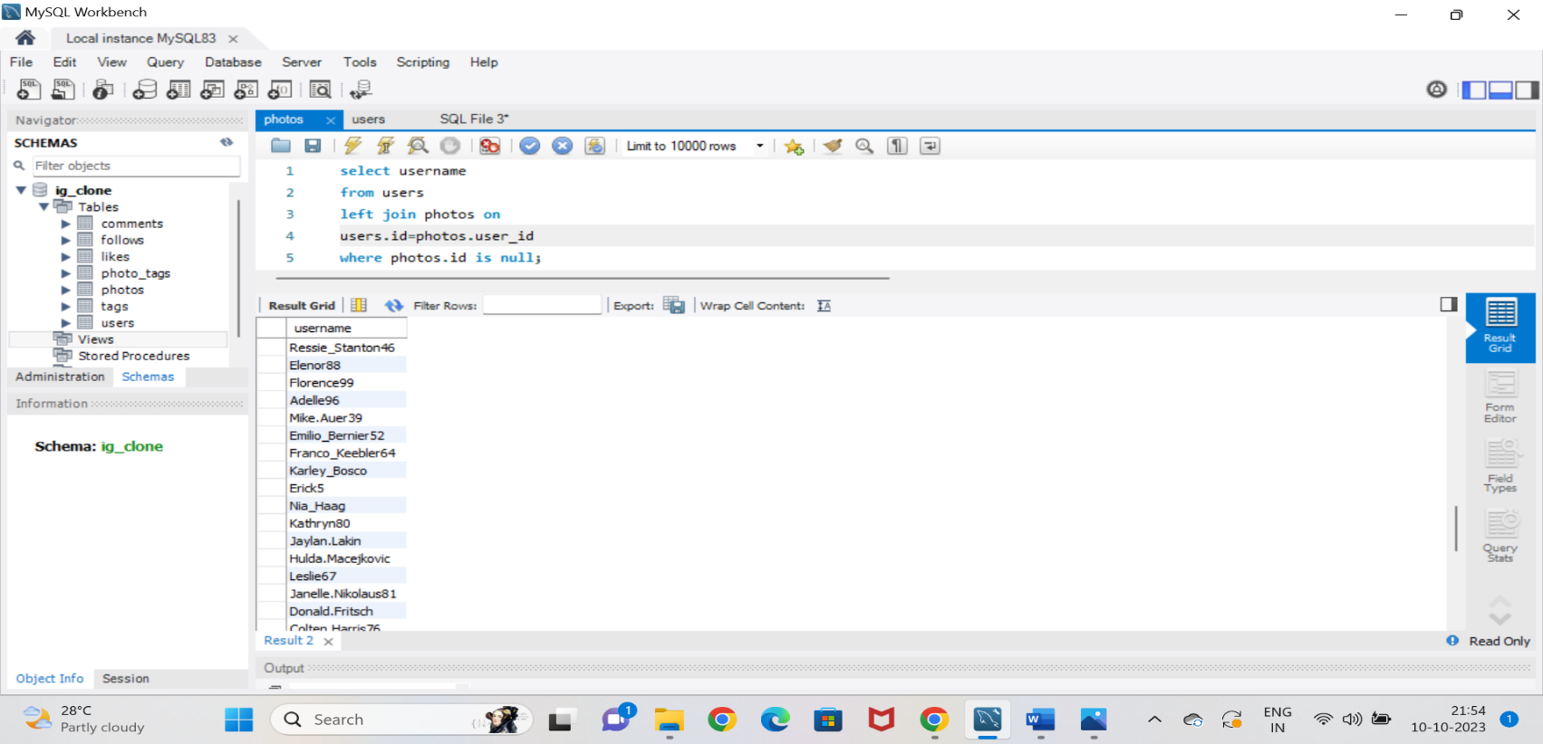

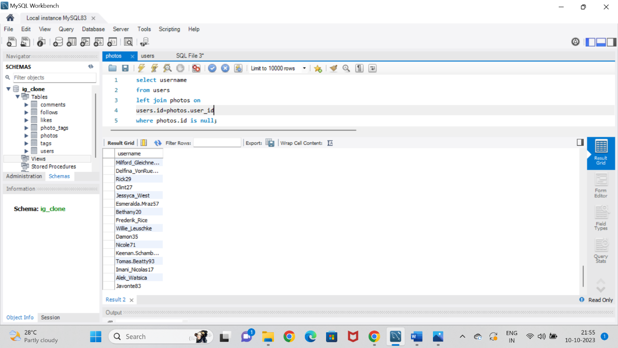

The following pictures shows the usename of all inactive users on Instagram.

1. **Contest winner Declaration:**

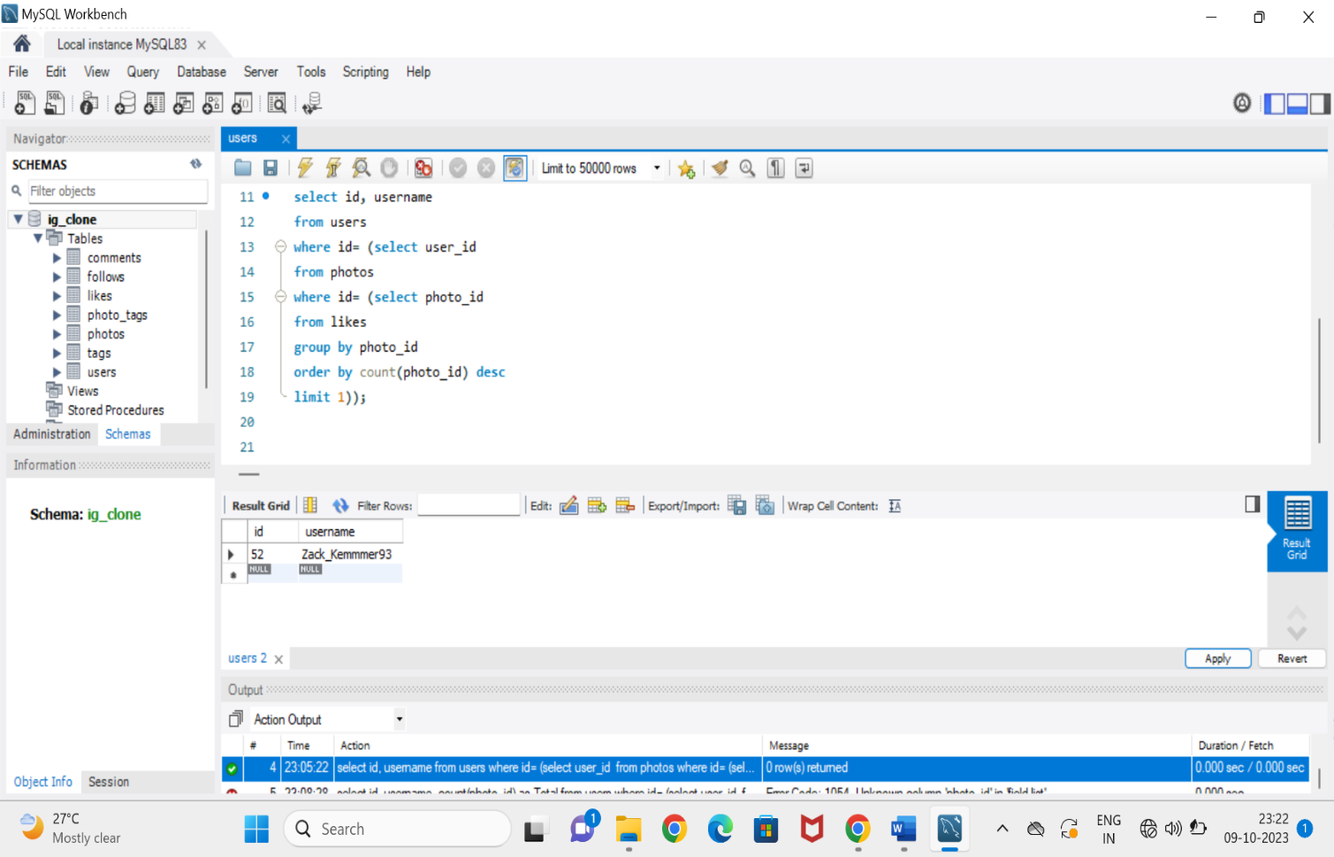

The winner of the contest is Zack_Kemmer93

1. **Hashtag Research:**

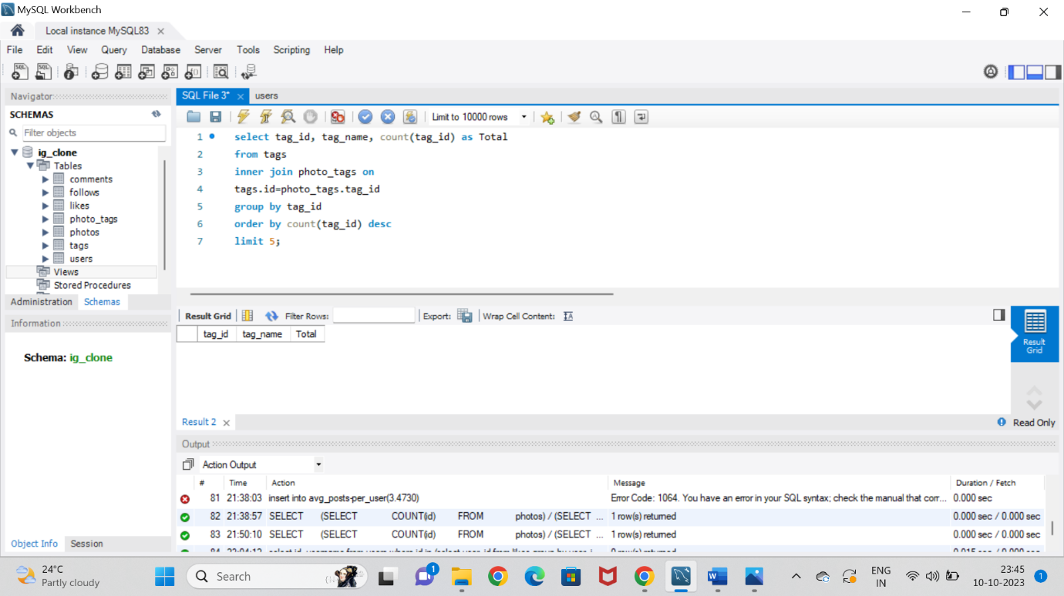 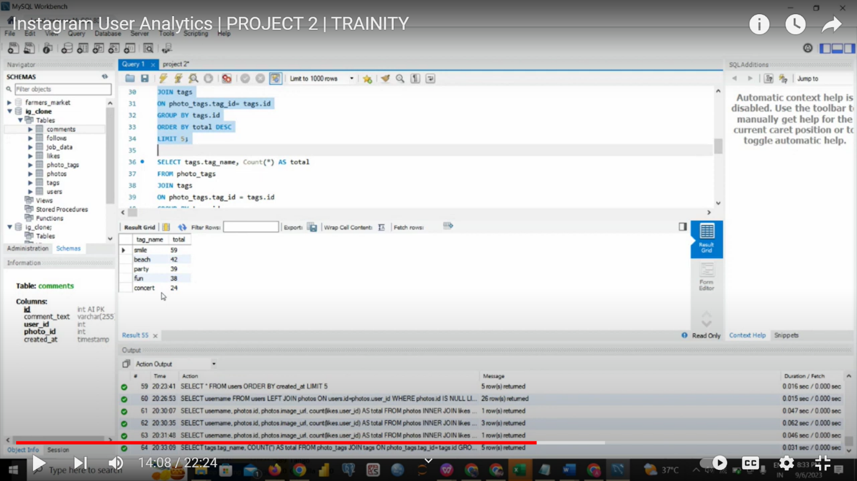

Famous top 5 Hashtags are smile, beach, party, fun, concert.

1. **Ad Campaign Launch:**

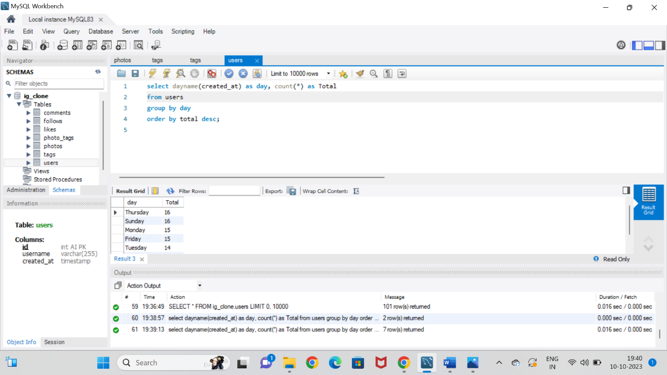

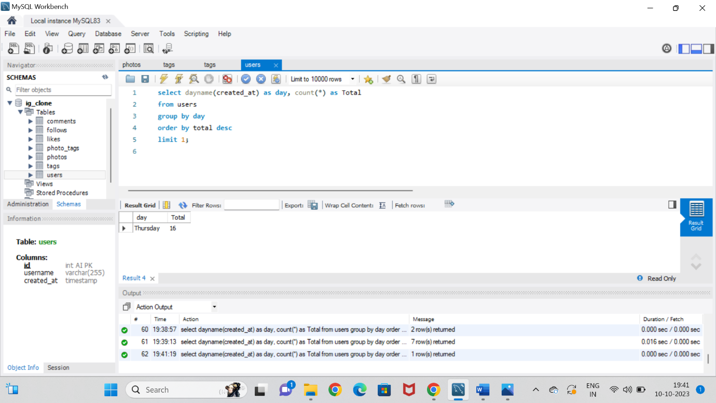

The most suitable day for the team to launch the ads is on Thursday.

1. **Investor Metrics:**
2. **User Engagement:**

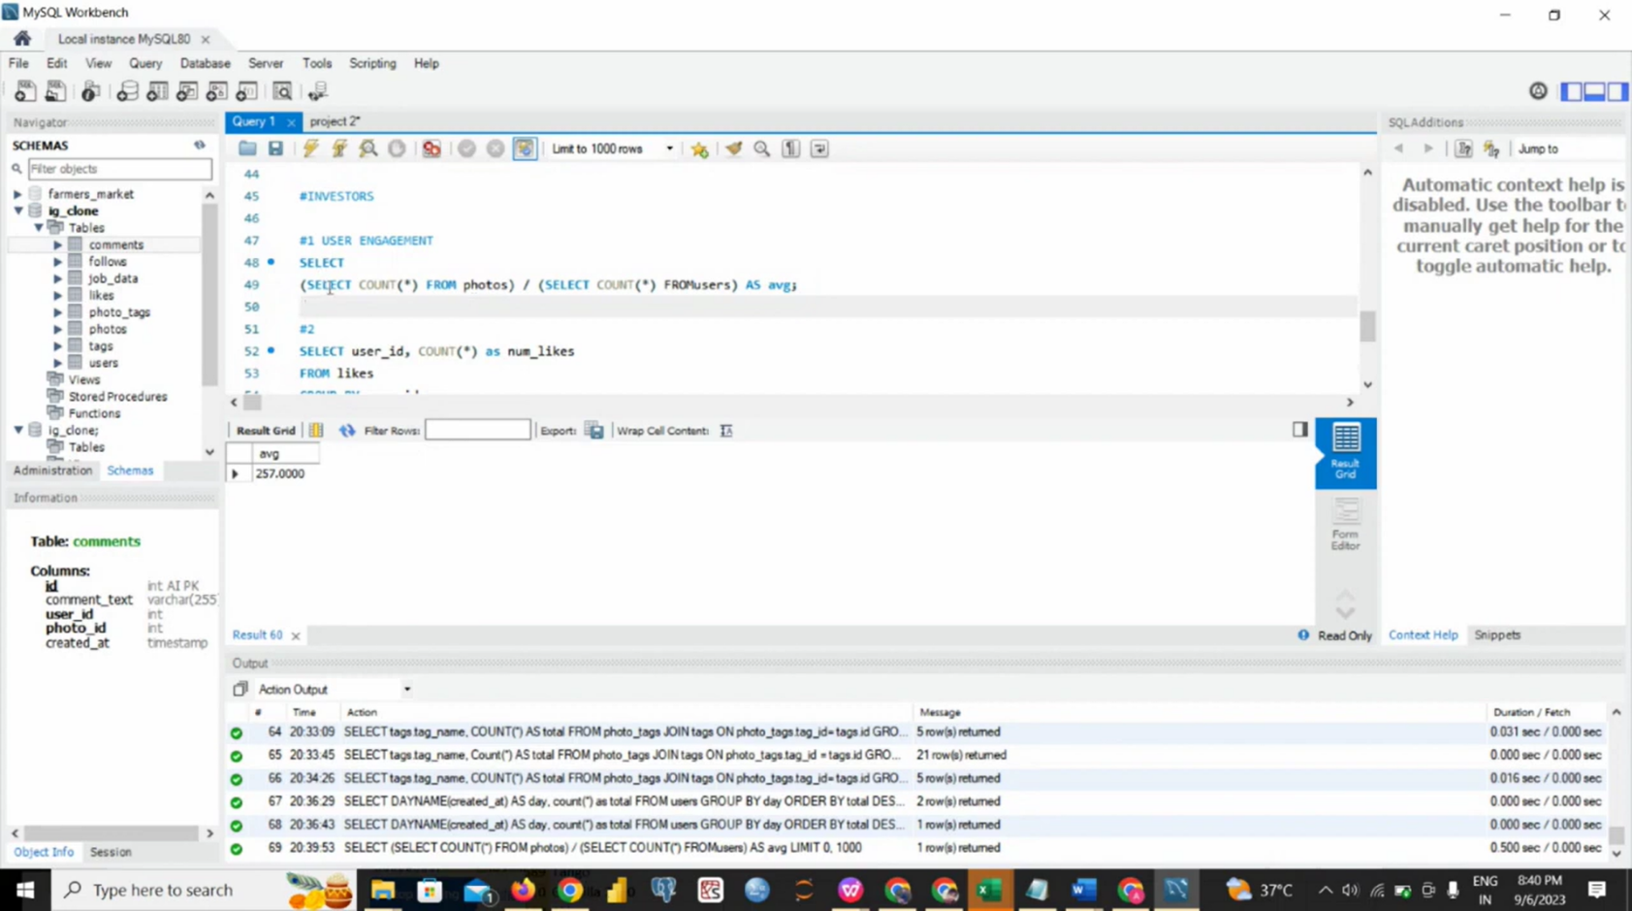

The Average number of posts per user on Instagram are **257.000**

1. **Bots and Fake Accounts:**

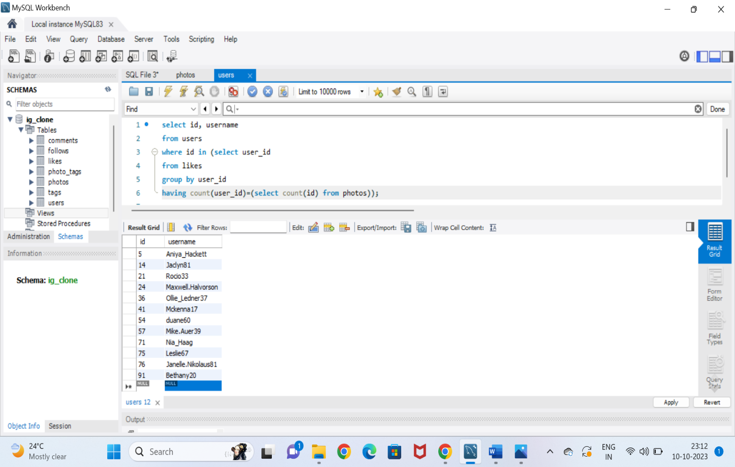

The fake accounts noticed are Aniya_Hackett, Jacln81, Rocio33, Maxwell.Halvorson, Ollie_ledner37, Mckenna17, Duane60, Mike.Auer39, Nia_Haag, Leslie67, Janelle.Nikolause81,, Bethany20

All the above insights are produced by executing the sql queries. From the pictures we are able to notice the loyal users, inactive users, winners of the contest, familiar hashtags, average posts per users and fake Instagram accounts.

**Results:**

From the project “Instagram User Analytics” we are able to derive the information using sql. I have learnt and clearly understood the process of executing the queries and getting the accurate outputs. This gave me hands on experience on sql by analyzing the data and providing valuable insights. So I conclude that my knowledge on SQL has improved.